Name : Aneel kumar

ID no : BIT-23F-033

Teacher Miss Aqsa

Lab no : 07

# LAB 07

Write a Python function that draws a square using asterisks (*). The side length of the square should be provided by the user.

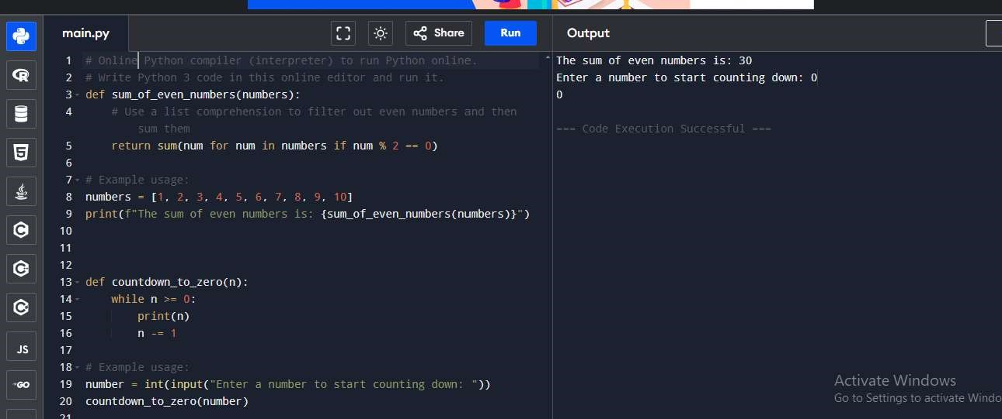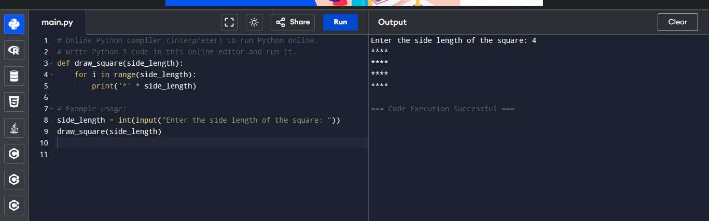Write a Python function that takes a list of numbers as input and returns the sum of only the even numbers.

task3.

Write a Python function that takes a number as input and counts down to zero, printing each number